30.37: a) 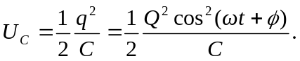
b) 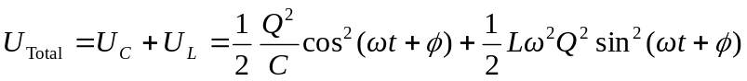
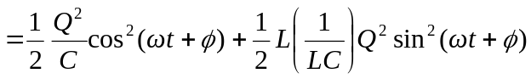
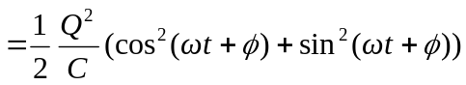
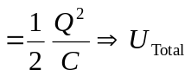 is a constant.

